English Title (Arial 18-Point)

Bending Tests of Composite Panels Reinforced with Orthogrid/Isogrid Carbon Fibers

First Author ¹, Second Author ¹, and Corresponding Author ^{2*} (Arial 11-point)
¹Affiliation-1 (Times New Roman 10-point)
²Affiliation-2 (Times New Roman 10-point)
Rattapol Sakornsin ¹ and Siripong Atipan ^{2*}
¹Department of Mechanical Engineering, Faculty of Engineering at Sriracha, Kasetsart University Siracha Campus
199 Moo 6, Sukhumvit Road, Tung Sukla, Sri Racha, Chon Buri, 20230 Thailand
²Department of Aerospace Engineering, Faculty of Engineering, Kasetsart University,
50 Ngamwongwan Rd. Ladyao, Chatuchak, Bangkok, 10900 Thailand
Email address: rattapol@eng.src.ku.ac.th (Rattapol Sakornsin), siripong.a@ku.th (Siripong Atipan)

ABSTRACT: Each paper should have abstract (not exceeding 200 words). The abstract should appear at the beginning of the manuscript. They should not only indicate the subject and scope of coverage but also, in the case of research papers, give major results and conclusions. Times New Roman 11-Point
ABSTRACT

Abstract Context: Times New Roman 10-Point)
This research is part of the WIG Craft Type C design and construction project at Kasetsart University. To get strong, stiff, and weigh efficient structure, composite panels reinforced with orthogrid fibers or isogrid fibers will be applied to the design of WIG Craft’s fuselage and wing structure. To do this, the properties of the composite curved panels needed to be studied and one of the important properties is bending property. The objective of this study is to perform experimental bending tests of composite curved panels reinforced with orthogrid/isogrid fiber panels. The specimens include composite carbon fiber curved panels of 30x40 cm² reinforced with corrugated grid carbon composite panels of various grid direction e.g. 0°, 90°, and ±45°, and cured either at room temperature or under heated and pressurized in an autoclave. For each test, compression normal loads are applied up to its ultimate loads. The bending deformation and the normal loads are measured and compared with each other including those of non-reinforced composite panels. The test results are also examined and applied to the bending analysis models.
Keywords: Several keywords (no more than 5 words) for the paper should be given below the abstract. Times New Roman 10-Point.
Keywords: Reinforced Composite Panel, Stiffened Composite Panel, Isogrid Structure, Orthogrid Structure, Bending Test

Text Format: The title of each section should be numbered by I, II, III and placed in the middle of a line (all capitals in Times New Roman 11-Point.) Titles of sub-sections are placed to the left with or without a preceding number. Times New Roman 10-Point.
I. INTRODUCTION
Iso-grid structure, patented by McDonnell Doulas Corporation, is constituted with a thin metal panel reinforced with lattice of triangular stiffening ribs forming an array of continuous equilateral triangles [3]. It has been widely used in aerospace application since 1970s as its advantages of light weight, high strength, high stability, great energy absorption, and low-cost manufacturing. Composite iso-grid and ortho-grid structures were found in the late 1970s and widely developed in early 1990s. Composite materials particularly have advantages for this type of structure as the typical stresses in grid stiffened structure’s ribs are highly directional along the rib axis. The high directionality of composite materials allows for the majority of the material’s stiffness and strength to be directed along this directional axis, leading to an increase in its strength [4].

II. SETUP AND METHODOLOGY
Seven test specimens were made with different configurations specified in Table 1. Each test specimens were made from 4 layers of carbon fabrics of TR 30S 3L type (Mitsubishi Chemical Corporation) and lay up in direction of 0°/90° using epoxy YD128:ACCEL618 (mixing ratio 5:3).
Table 1 Configurations of the test specimens(Arial 10-Point)
Test Specimens | Grid Types & Directions | Fabric Directions | Curing Processes | Panel  Dimension | Grid Dimension |  |  | Weight  (g)
 |  |  |  |  | h (mm) | w (mm) | d (mm)
PCP-301 | Plain Curved Panel  (No Stiffened Grid) | 0°/90°  (4 Layers) | Room Temp. at 30°C/1bar | 30 x 40 cm² | - | - | - | 195
OGU-301 | Ortho-Grid  0° (Uni-direction) | 0°/90°  (2+2 Layers) | Room Temp. at 30°C/1bar | 30 x 40 cm² | 10.0 | 73.9 | - | 242
OGU-904 | Ortho-Grid  0° (Uni-direction) | 0°/90°  (2+2 Layers) | Autoclave at 90 °C/4 bars | 30 x 40 cm² | 10.0 | 73.9 | - | 241
OGS-301 | Ortho-Grid  0°/90° (Square) | 0°/90°  (2+2 Layers) | Room Temp. at 30°C/1bar | 30 x 40 cm² | 10.0 | 73.9 | 74.9 | 259
OGS-904 | Ortho-grid  0°/90° (Square) | 0°/90°  (2+2 Layers) | Autoclave at 90 °C/4 bars | 30 x 40 cm² | 10.0 | 73.9 | 74.9 | 258
IGT-301 | Iso-Grid  ±45°/0° (Triangle) | 0°/90°  (2+2 Layers) | Room Temp. at 30°C/1bar | 30 x 40 cm² | 10.0 | 75.3 | 125.1 | 269
IGT-904 | Iso-Grid  ±45°/0° (Triangle) | 0°/90°  (2+2 Layers) | Autoclave at 90 °C/4 bars | 30 x 40 cm² | 10.0 | 75.3 | 125.1 | 271

The authors are requested to submit professional quality illustrations with sharp lines and good contrast. Once the paper is accepted, the authors should promptly supply original copies (or electronic files) of all illustrations. All illustrations should be numbered, titled and have descriptive captions. Illustrations may be reduced to a 8-cm column width. It is therefore important that lettering be legible after reduction by as much as 4:1.

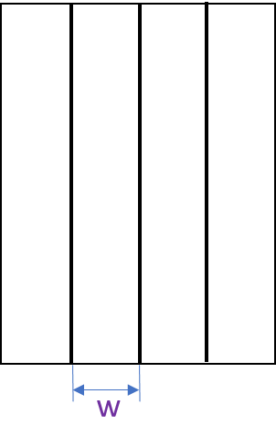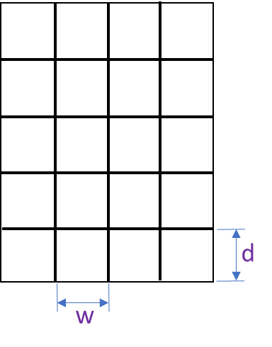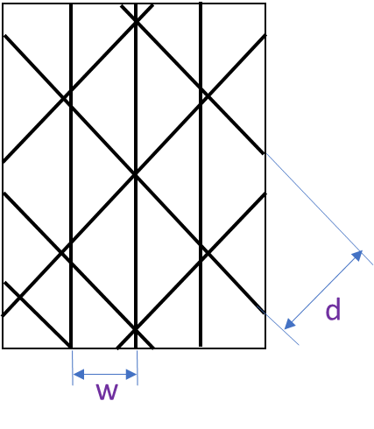
- OGU (b) OGS (c) IGT
Figures 1 Grid arrangements of stiffened grid panels, (a) Unidirectional ortho-grid panel, (b) Square ortho-grid panel, and (c) Iso-grid panel (IGT) (Arial 10-Point)
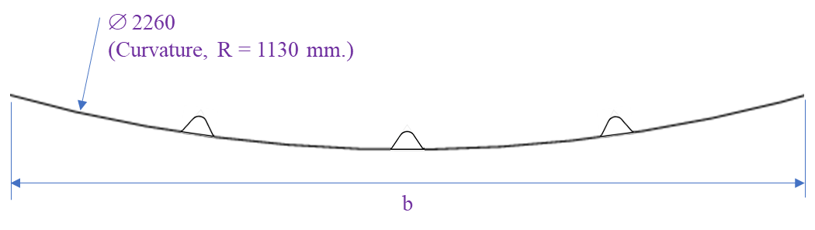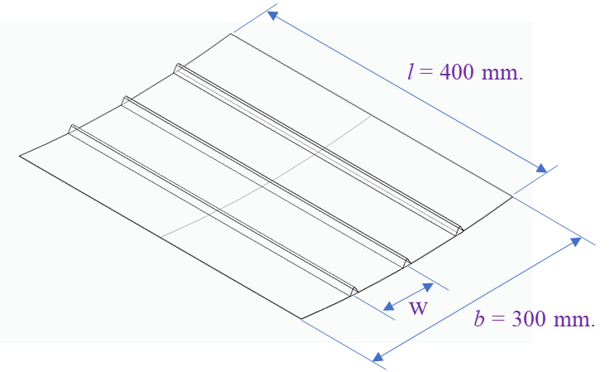
Figure 2 Cross section and dimension of the stiffened curved panels
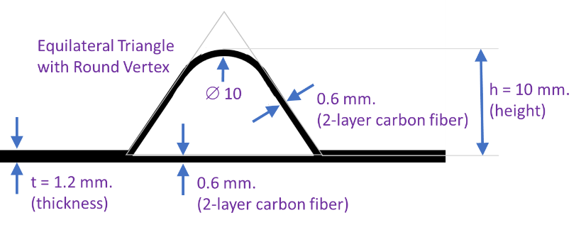
Figure 3 Cross section of the grid stringer of the ortho-grid and iso-grid panels
III. RESULTS AND DISCUSSION
To make the test results meaningful, it is necessary to transform the loading force and deflection displacement to flexural stress and strain. These were done for PCP-type and OGU-type specimens using the analysis of thin-walled beam [1] and the analysis of stiffened curved panel [2] as the following formulas.

All equations and mathematical formulas should be typewritten. Equations should be numbered serially on the right hand side by Arabic numerals in parentheses. Leave proper space above and below all of the mathematical expressions.

$q_{t}=\frac{q_{v}}{2sin⁡()}$ , where $q_{v}={\left(\frac{M_{x}}{I_{x}}\right)}^{2}\frac{δl_{h}y_{c}}{E}$ (1)
$σ=\frac{q_{t}}{δφ}={\left(\frac{M_{x}}{I_{x}}\right)}^{2}∙\frac{l_{h}{∙y}_{c}}{φ∙E}∙\frac{1}{2sin⁡(β)}$ , where $φ=2β$ (2)
$ε=\frac{∆l}{l_{h}}$ , where $∆l=2×\left(\sqrt{{\left(\frac{l_{h}}{2}\right)}^{2}+{\left(∆y\right)}^{2}}-\frac{l_{h}}{2}\right)$ (3)

IV. CONCLUSIONS
Present work studies bending properties of carbon composite curved panels reinforced with grid stiffened panels of various grid configurations using 3-point bending test technique. The tested specimens, unidirectional ortho-grid panels (OGU), square ortho-grid panels (OGS), iso-grid panels (IGT), and plain curved panel (PCP), were fabricated and cured under either room temperature or heated and pressurized control in autoclave.

ACKNOWLEDGMENTS

Acknowledgments should be kept in minimum words and be given as a paragraph at the end of the text.

Kasetsart University supports this work with contract number of xxxxx. The authors would also like to special thank to Prof. X for his technical support to construct test carbon fiber composites material.

REFERENCES

References should be numbered in the order in which they are cited at the end of the manuscript in the following format:
a. The format of author name should be last name followed by the first initials.
b. Journal name must be in italics and cannot be abbreviated.

For a Journal:
[1] Pekins CD, “Development of Airplane Stability and Control Technology,” Journal of Aeronautics, Astronautics and Aviation, Vol. 7, No. 4, 1970, pp. 290-301.

For a conference preceedings:
[2] Bakker JT, “Effect of Control System Delays on Fighter Flying Qualities,” AGARD Conference Proceedings, No. 333, 1982, pp. 18-1 to 18-16.

For a technical report:
[3] Medioni GR, “Segmentation of Images into Regions Using Edge Information,” Tech. Rep. 101, Intelligent Systems Group, University of Southern California, Los Angeles, Mar. 1983.

For an authored book:
[4] Huenecke K, Modern Combat Aircraft Design. Annapolis, Maryland, Naval Institute Press, 1987, Chap. 13, pp. 237-249.

For an article in an edited book:
[5] Wittman JH, “Analysis of a Hybrid Frequency-Time Hopping Random Access Satellite Communication System,” Spread Spectrum Techniques, R. C. Dixon, Ed., New York, NY, IEEE Press, 1976, pp. 193-200.

[1] Strigunov V. M. Theoretical and experimental study of the operation of thin-walled beams Proceedings of TsAGI, issue 349, 1938.
[2] Strigunov V. M. Research of local stresses in the elements of aircraft structures from various materials Proceedings of the MAI, issue 22, 1953.
[3] Meyer, R. R., Harwood, O. P., and Orlando, J. L., “Isogrid Design Handbook” NASA CR-124075, February 1973.
[4] Huybrechts S.M., Hahn S.E. and Meink T.E., 1999. Grid stiffened structures: a survey of fabrication, analysis and design methods, Proceedings of the 12th IECH.
[5] Sara Piculin, Franc Sinura, Primož Može, “Analysis of Stiffened Curved Panels in Compression – A Preliminary Numerical Study for Experimental Tests”, EUROSTEEL 2017, September 13–15, 2017, Copenhagen, Denmark.
[6] Aniket S. Umap, Vijay S. Pisal, Ghanshyam G. Rathod, Ganesh R. Sonawane, R. R. Arakerimath & Sajal Roy, “Stress and Deflection Analysis of Orthogrid and Isogrid Structure”, ICRRM 2019 – System Reliability, Quality Control, Safety, Maintenance and Management pp. 153–158.

